CentRes POS

# **Status Update: Sprint** 2 **– Week** 2

**Submitted by:** S. Andy Short

## **TRELLO BOARD**

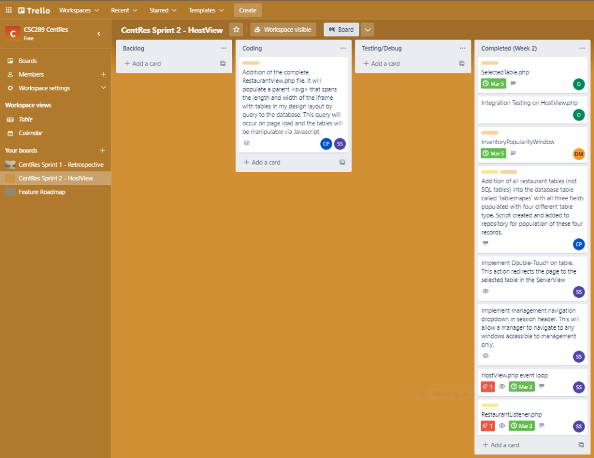

## **STATUS UPDATE DETAILS**

### **Tasks Accomplished**

1. Implemented WaitTimes.php
2. Implemented SelectedTable.php
3. Implemented WaitList.php
4. Implemented InventoryPopularityWindow.php
5. Integrated HostView and ServerView. Manager can double-click/pointerdown on a seated table in the HostView. It takes the manager to that table in the ServerView. If the ticket is removed while the manager is viewing the table/ticket, an alert appears before redirecting them back to the HostView.
6. Added a manager navigation dropdown to the top title bar beside logout button.
7. Linked InventoryPopularityWindow.php in manager navigation dropdown.
8. Reimplemented multiselect for tables in RestaurantLayout.php, using drag instead of double-click/pointerdown.
9. Changed table styles to accommodate being both highlighted and selected. Highlighted occurs when a server is selected in ifrServerList.

### **Problems/Challenges (include status – “resolved/not resolved”)**

1. Logout button on InventoryPopularityWindow.php doesn’t work. InventoryPopularityWindow was integrated late Sunday night. Upon testing this problem was discovered. **UNRESOLVED** This problem will be fixed early in the week.

2. Aesthetics and accessibility with regards to RestaurantLayout.php. In order to facilitate 3 independent state groups, the tables were styled to be somewhat transparent by default. Selecting a table will bring its opacity up to 100%. Selecting a server in the server list will add an animated red border around any table assigned to that server. When multiselect engages, the layout blurs. This solution is not very aesthetic and will be discussed at the meeting Tuesday. **UNRESOLVED**

3. In InventoryPopularityWindow.php, what number do we display if an untracked menu item and a tracked item are selected together? **RESOLVED** quantity field will be blank, have a placeholder of “Conflict”, and a class of “conflict”.

4. In InventoryPopularityWindow.php, what number do we display if multiple tracked items are selected with different quantities? **RESOLVED** quantity field will be blank, have a placeholder of “Multiple”, and have a class of “multiple”.

5. Who is responsible for refreshing the iframes in ServerView? As it is currently implemented, each iframe is responsible for refreshing itself periodically. HostView has the option to manually refresh any iframe if it receives an appropriate message to make a state change. **LOCKED/RESOLVED** The current solution works, but it would look better if HostView updated the individual iframes periodically at the same time. The rework to accomplish this task has been given a **C** **MOSCOW** priority, and will be revisited only if all remaining tasks are accomplished ahead of the Sprint Demo.

